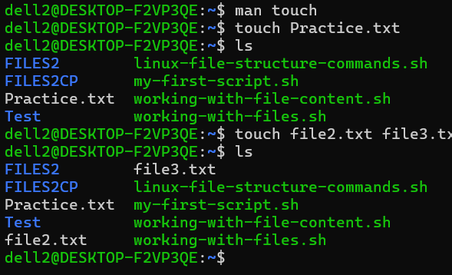
The screenshot above shows touch as a command used to create files and ls is a command used to check the content of the file.
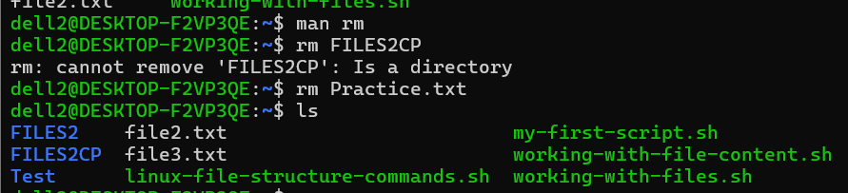
The command rm is used to remove files as illustrated above where Practice.txt is being removed
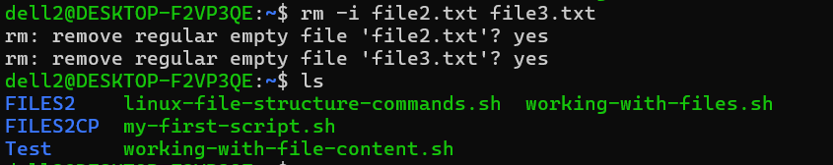
In order to remove multiple files you could use the command rm -I and then you list the files you want to remove. Whereby -i is considered the interactive mode ( remove regular empty file ‘file2.txt’?)
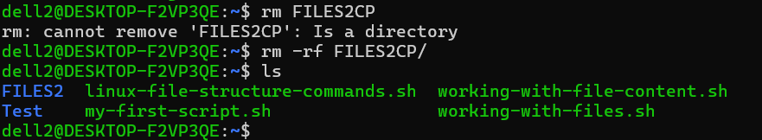
Rm rf where the r is recursive and f means force in the rm -rf command to remove a directory.
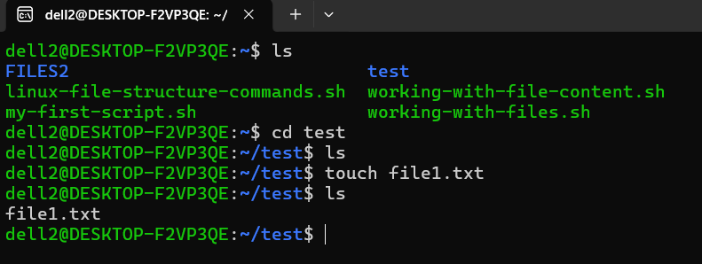
To create a file within a directory for example in the directory test. You need to first move to that directory test using the command cd as shown above. Then you can use the touch command to create file in there.
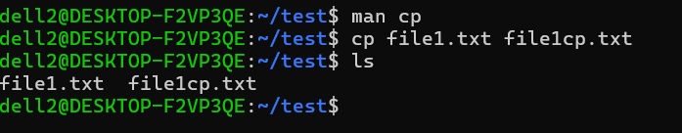
The image above shows the command cp which is used to copy a file which is clearly illustrated above where file1.txt is copied to file1cp.txt in the same directory
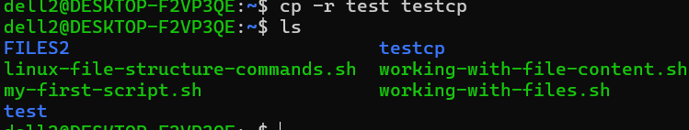
The image above shows a command cp -r test testcp that is used to copy the test directory to another copy testcp. as shown above. The testcp directory will have the same content as the test file as shown below.
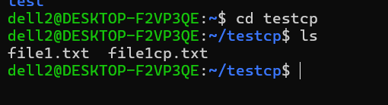
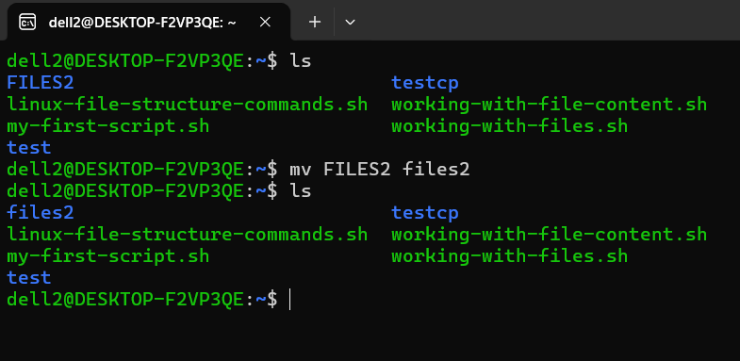
The image above shows the command mv that is used to move or rename a file. As you can see above the FILES2 directory has been renamed to files2
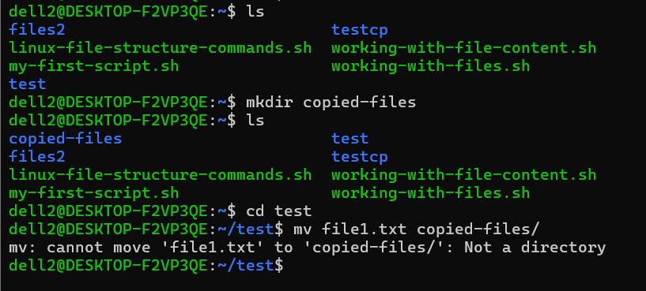
I tried moving the file1.txt to the copied-files directory and a not such a directory error occurred because, You're now inside the test directory (~/test), but the copied-files directory was created in your home directory (~), not inside test.
From inside test, there is no copied-files directory (or at least not one that mv can see as a directory at that relative path). The trailing / tells mv to treat the target as a directory. Since it doesn't find a directory with that name in the current location, it gives the "Not a directory" error.
INSTEAD YOU COULD DO AS BELOW
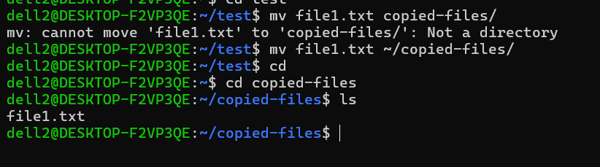
Where ~ means the home directory

